L1 Speaking & Listening (Role-Play) – about 12-15 minutes
Part of the speaking exam is to take part in a role-play with other students (2 or 3)- informal discussion & formal discussion
The teacher will read the scenario and you will be able to read it at the same time (you can ask the teacher to read the task again)
To make sure all students understand what they have to discuss, it’s advisable that one student summarises what the topic is.
For example, they can say:
‘Right. What we have to discuss today is……’
This is a task that was given to students one year:
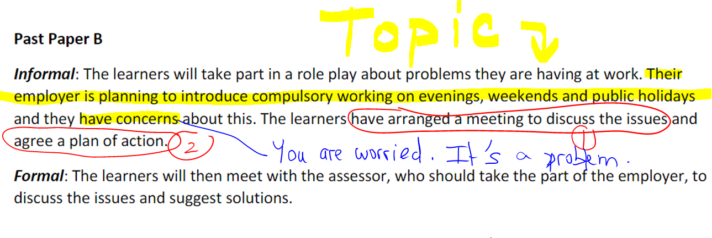
To keep the conversation going, you need to think outside the box!
- Try to imagine the situation
- Give examples, times, past personal experience
- Use past tenses- past simple / past continuous (to talk about past experience
- Reasons why you disagree
- Comment on each other’s ideas
- Also, try and see the employer’s point of view (I understand why….)
Then, at the end of the discussion, you need to make a plan of action (in a few sentences, each of you will say what they will talk about with the manager- issues, questions, requests)
1) The informal group discussion will last about 7-10 minutes.
2) Then, there will be a formal discussion, where you need to use formal language (4-5 minutes). Every student needs to take part and express their views formally. (introduce yourself formally, explain the issues, make suggestions and propose solutions)

